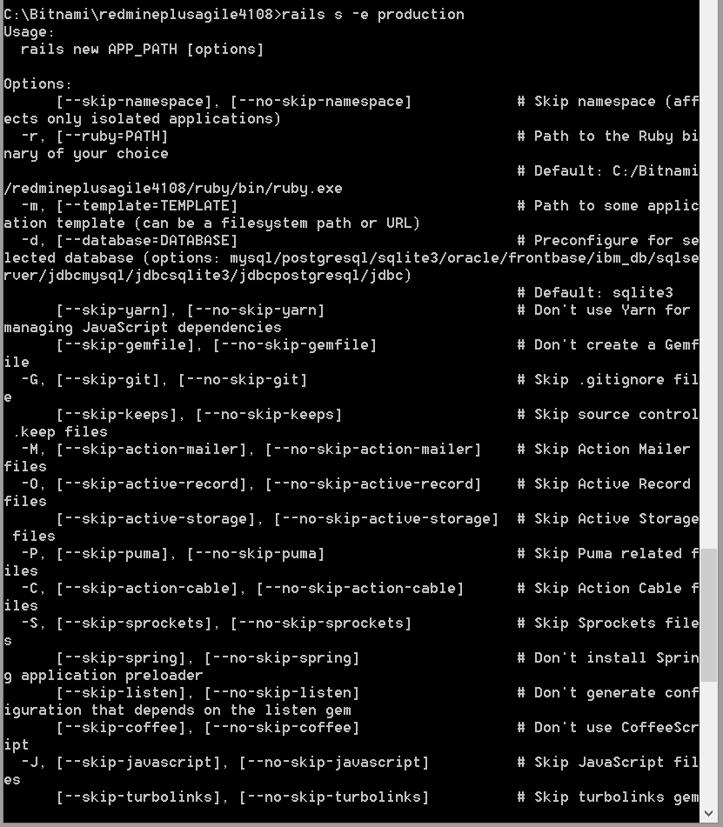
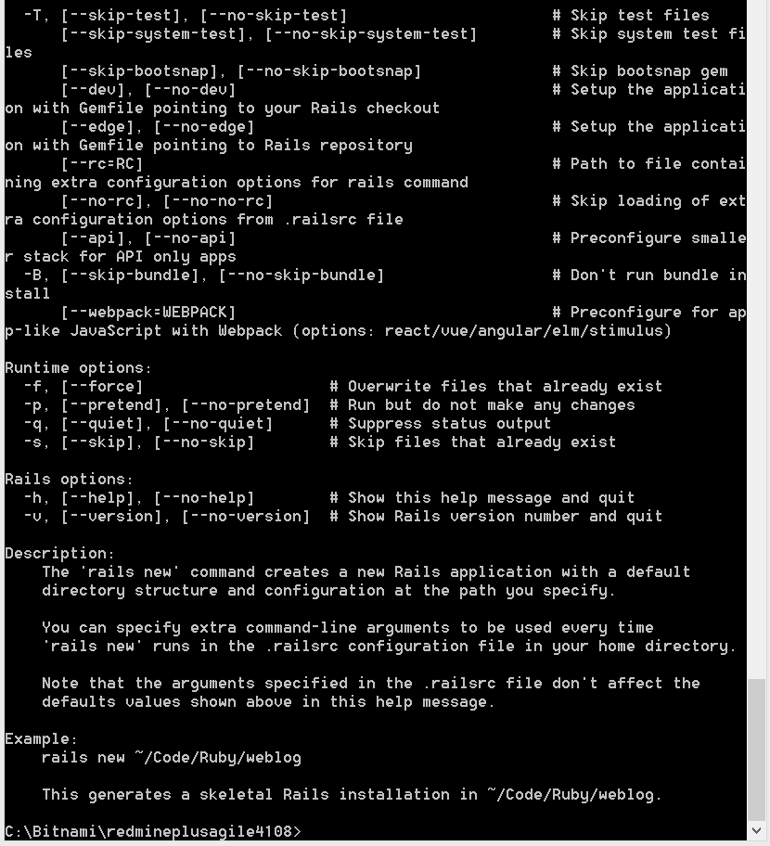

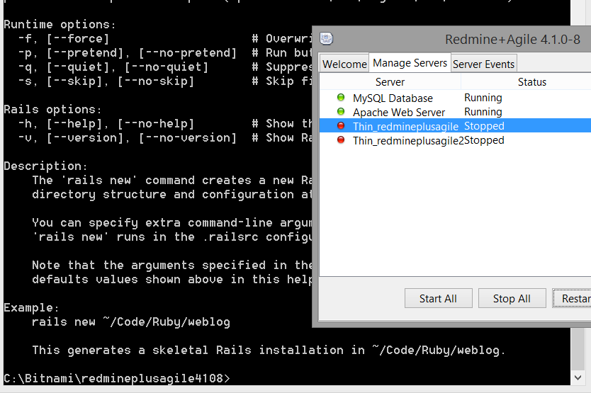

Still thin servers does not work.

I try one more time upload the plugin.
It gives the following error as I mentioned. (System has data at this time) It culd not finalize the upload of the plugin.
