New installation
Plugins folder. Agile comes with the program itself. Redmine Plus Agile (Bitnami – 4.1.0-8)
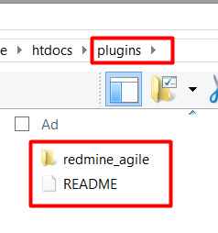
It is working.
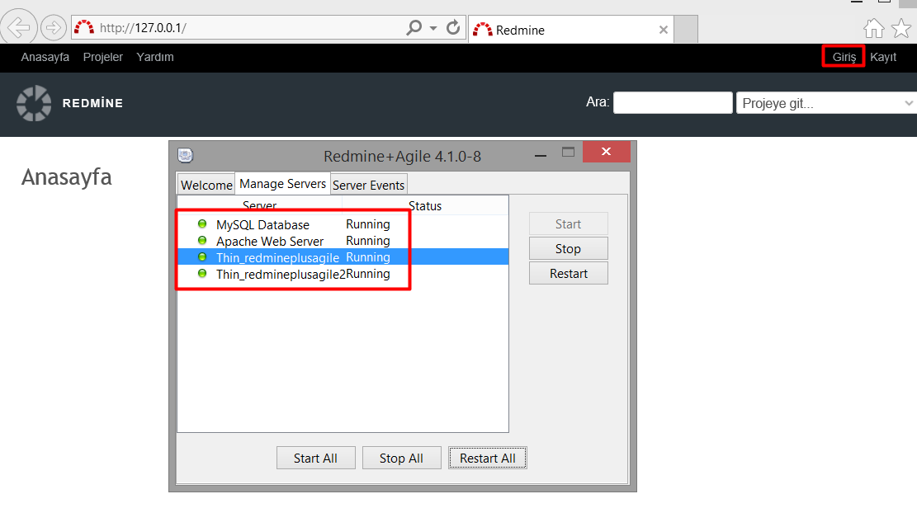

There is no issue or Project.
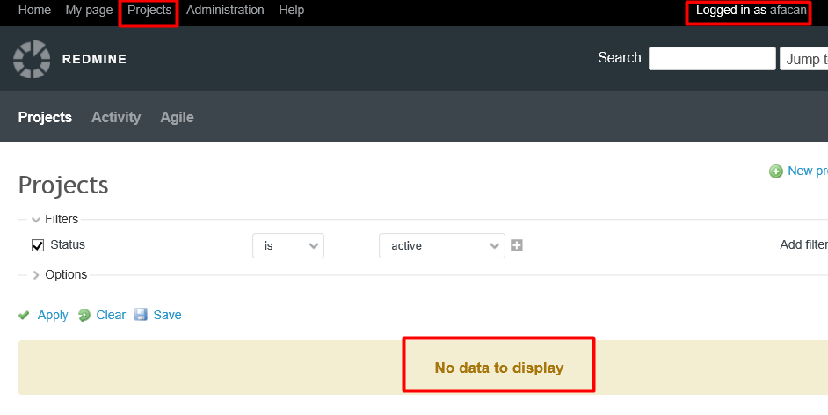
Copied the plugin
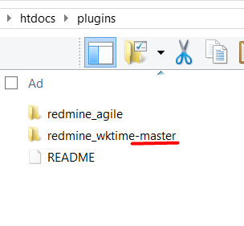
Delete the –master
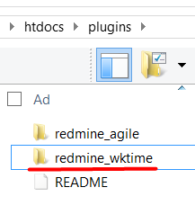
Go to the plugins directory
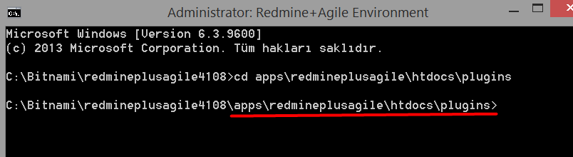
Bundle install
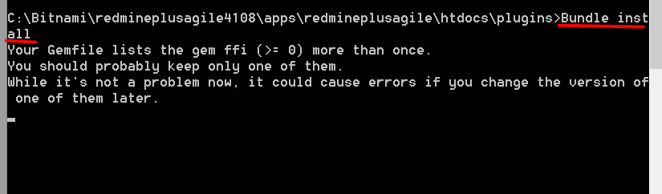
Gives the warning for the below mantioned gems about source.
Et-orbi
Raabro
Fugit
Rufus-scheduler
It is saying that you should restrict this gem toyour preferred source. And this source I think should be http: not https:. Did you use this gem from http: source? What shoul I do? How can configure and restrict the gems?
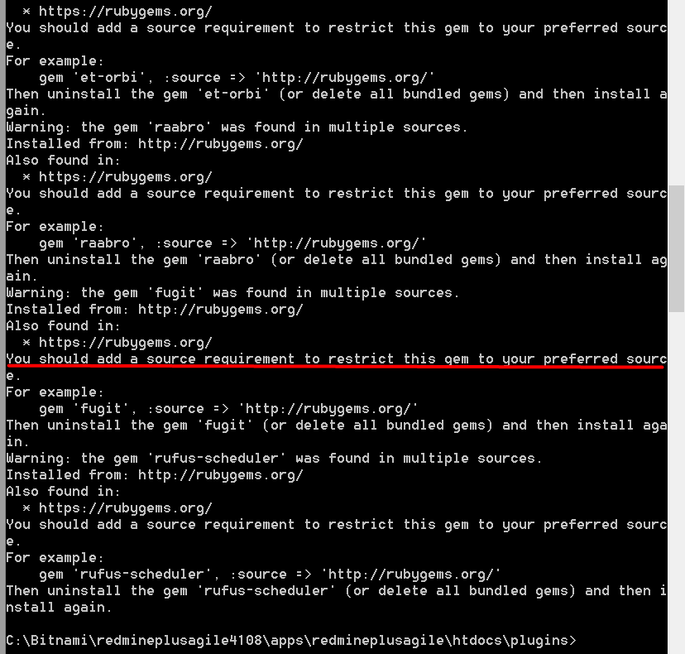
I have red the sites.
https://github.com/rubygems/bundler/issues/3585
https://github.com/rubygems/bundler/pull/3592/files/25bf713bf071665b02e4817aeece7951e7bf5b22#diff-ec267c71117bf68f38c928a3691ba98c

and I saw that if I rant he bundle install one more time there will be no warning.
I did. It was correct. There was no warning.
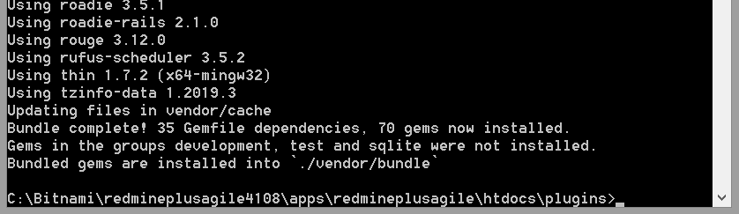

MIGRATE
rake redmine:plugins:migrate NAME=redmine_wktime RAILS_ENV=production

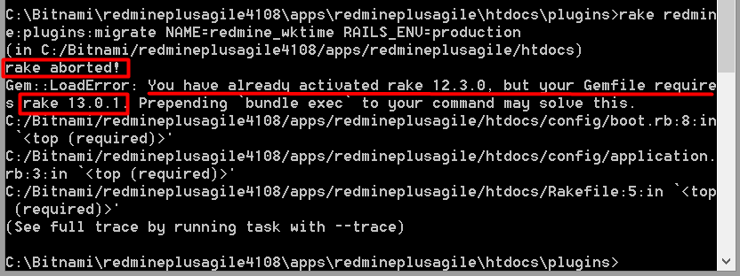

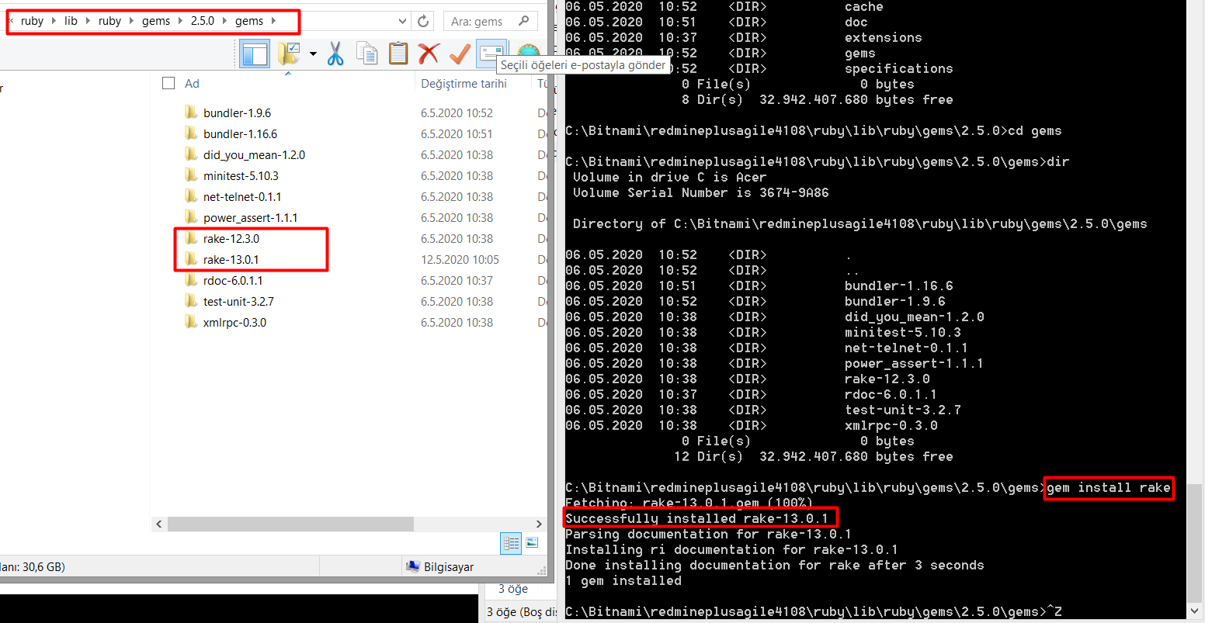
MIGRATE again
It displays an explanation for some just I could read “……already initiliazed.” Then the result.
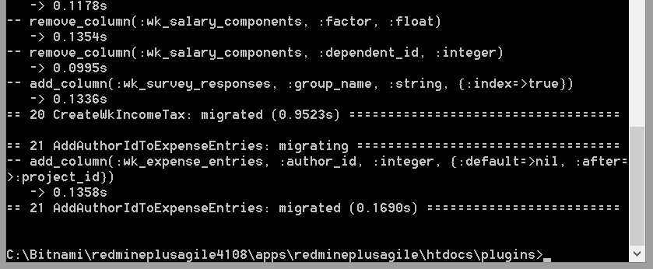
Restart the servers / Redmine
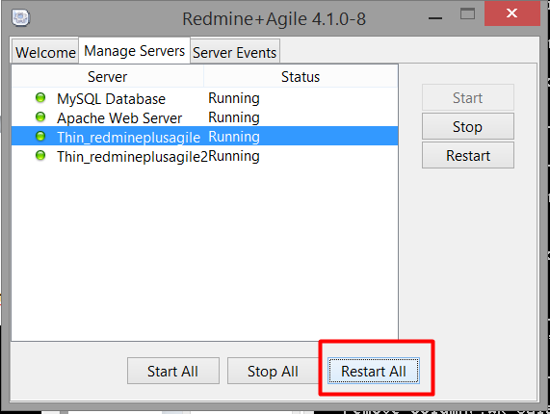
No problem it can be seen under plugins.
